Article title in Spanish
Article title in Portuguese. Article title in English

First and last name University. Country.
Email

RESUMEN
Introducción: Texto de un único párrafo, máximo 250 palabras, (Calibri 11 pt, justificado e interlineado sencillo). Metodología: (Calibri 11 pt, justificado e interlineado sencillo). Resultados: (Calibri 11 pt, justificado e interlineado sencillo). Conclusiones: (Calibri 11 pt, justificado e interlineado sencillo).

Palabras clave: palabra clave 1; palabra clave 2; palabra clave 3; palabra clave 4; palabra clave 5; palabra clave 6, (separadas por punto y coma, Calibri 11 pt, justificado e interlineado sencillo)

RESUMO
Introdução: Parágrafo único, máximo de 250 palavras (Calibri 11 pt, justificado, espaçamento simples). Metodologia: (Calibri 11 pt, justificado, espaçamento simples). Resultados: (Calibri 11 pt, justificado, espaçamento simples). Conclusões: (Calibri 11 pt, justificado, espaçamento simples).

Palavras-chave: Palavra-chave 1; Palavra-chave 2; Palavra-chave 3; Palavra-chave 4; Palavra-chave 5; Palavra-chave 6 (separadas por ponto e vírgula, Calibri 11 pt, justificado, espaçamento simples)

ABSTRACT
Introduction: Single-paragraph text, maximum 250 words (Calibri 11 pt, justified, single-spaced). Methodology: (Calibri 11 pt, justified, single-spaced).
Results: (Calibri 11 pt, justified, single-spaced). Conclusions: (Calibri 11 pt, justified, single-spaced).

Keywords: keyword 1; keyword 2; keyword 3; keyword 4; keyword 5; keyword 6 (separated by semicolons, Calibri 11 pt, justified, single-spaced).

- Introduction (Mandatory heading. First-level heading. Calibri 12 pt, bold, justified, capitalized, single-spaced)
Regular text, regular text, regular text, regular text, regular text, regular text
1.2. Second-level heading. Calibri 12 pt, Arabic numerals, bold, justified, single-spaced)
1.1.1. Third-level heading. Calibri 12 pt, Arabic numerals, italics, justified, single-spaced)
2. Objectives (Mandatory heading. First-level heading. Calibri 12 pt, bold, justified, capital letters, single-spaced)

3. Methodology (Mandatory heading. First-level heading. Calibri 12 pt, bold, justified, capital letters, single-spaced)

4. Results (Mandatory heading. First-level heading. Calibri 12 pt, bold, justified, capital letters, single-spaced)

5. Conclusions (Mandatory heading. First-level heading. Calibri 12 pt, bold, justified, capital letters, single-spaced)

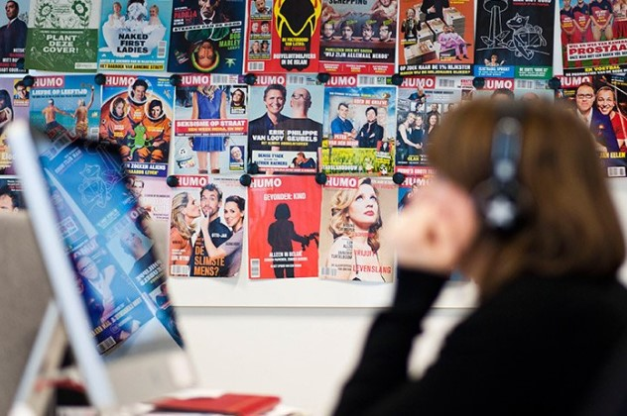
Figura 1. Figure title in Calibri 11 pt, centered, italics
Font: Calibri 11 pt. centered. (If web, as a hyperlink)

It will also be sent as a separate file in JPG format through the platform

Table 1. Table title in Calibri 11 pt, centered, italics)

Table text (Calibri 11 pt, normal,
single-spaced)

Tables and graphs must be editable

Direct quotation in the normal text of fewer than 40 words. Enclose the cited text in quotation marks. When there are more than two authors, only the last name of the first author is included, followed by et al. Direct quotation in the normal text of more than 40 words. Write the text in block form, without quotation marks, on a separate line, with a 1.25 cm left indent, without indenting the first line of the quotation. (Author's Last Name, Year, p. XXX)

REFERENCES (Required heading. First-level title. Calibri 12 pt, bold, left-aligned, capital letters, single-spaced)

ALL URLS OF MORE THAN 1 LINE MUST BE SHORTENED WITH https://bitly.com/ OR ANY OTHER LINK SHORTENER.

The journal adopts and adheres to the publication standards established in the 7th edition of the American Psychological Association (APA) style manual. You can also consult the APA style guide (PDF), prepared by the University of Alicante Library. All bibliographic references with a DOI (Digital Object Identifier) ​​must indicate this at the end, using a complete and secure URL link format, without prefixes or periods. You can check the DOI of a reference list on Crossref's Simple Text Query page.

As a general rule and recommendation, at least 60% of the references cited should be published in the last five years. There should be one blank space between references, single-spaced. When an author repeats the reference, their name will be rewritten, avoiding hyphens.

Examples:

Book
Pillet Capdepón, F. (2017). Geoliterature: Literary Landscape and Tourism. Síntesis.

Book chapter
Santos Santos, J.F. (2023). Don Quixote’s Windmills in 21st-Century La Mancha: Tourist Adaptation of the Environment. In L.A. Escudero, M.C. Cañizarez, & F. Cebrián (Eds.), An Approach to Rural Areas: Geographical Studies in Castilla-La Mancha (pp. 239-263). Aranzadi.

E-book
United Nations World Tourism Organization. UN Tourism (2024). International Tourism Highlights, 2024 Edition. https://www.e-unwto.org/doi/10.18111/97

Newspaper article
López, D. (October 24, 2024). Tourism De-seasonalization in Spain Advances Despite Record Summer. El País. https://elpais.com/economia/2024-10-12/la-desestacionalizacion-del-turismo-en-espana-.html
Journal article
Martín García, M.M. (2021). Golf Tourism in Almería and Its De-seasonalizing Effect. PASOS. Journal of Tourism and Cultural Heritage, 19(4), 763-773. https://doi.org/10.25145/j.pasos.2021.19.050

Web/blog article
Peñalver, J.L. (September 16, 2023). Top 5 Most Visited Tourist Websites in Spain. https://www.hosteltur.com/159131_top-5-de-los-sitios-web-turisticos-mas-visitados-de-espana.html

Conference presentation
Martínez Parra, B., & García Hernández, M. (2023). Usera, Madrid’s Chinatown. In Geography: Changes, Challenges, and Adaptation: Proceedings of the XVIII Congress of the Spanish Association of Geography (pp. 1,451-1,461), Logroño, September 12-14, 2023. Spanish Association of Geography & University of La Rioja. https://www.unirioja.es/

Academic thesis
Olivares de la Fuente, L. (2015). War Tourism: The Case of Berlin. Bachelor’s Thesis, University of Valladolid. E-Archivo. https://uvadoc.uva.es/handle/10324/13795

Report
Exceltur. Alliance for Tourism Excellence. (2024). Barometer of Profitability and Employment in Spanish Tourist Destinations: Summer 2024 Report.

Author contributions:
Conceptualization: Last Name, First Name. Software: Last Name, First Name. Validation: Last Name, First Name. Formal Analysis: Last Name, First Name & Last Name, First Name. Data Curation: Last Name, First Name. Writing – Original Draft: Last Name, First Name. Writing – Review & Editing: Last Name, First Name. Visualization: Last Name, First Name. Supervision: Last Name, First Name. Project Administration: Last Name, First Name.

All authors have read and approved the published version of the manuscript: Last Name, First Name.

Funding: This research received or did not receive external funding.
Acknowledgments: Example: This text was developed within the framework of a CONCILIUM project (931.791) at the Complutense University of Madrid, “Validation of Communication Models, Companies, Social Networks, and Gender.”

Conflict of Interest: If applicable.

