Title in English (Arial Black 14, bold)
Title in Spanish (Arial 12, bold)

Name and Surname author1
Institution
e-mail
Name and surname author2
Institution
e-mail

Received: xx/xx/xxxx
Accepted: xx/xx/xxxx
Published: xx/xx/xxxx
ABSTRACT
Abstract must be written in Calibri Light, 10 Pts, and justified. Must be written in direct style, reflexing the purpose of the research, the most important methodological aspects and the most important results achieved. Maximum: 300 words.
KEYWORDS
Between three and five keywords splitted by a semicolon that have been extracted from ERIC Thesaurus.
RESUMEN
The abstract translated into Spanish.
PALABRAS CLAVE
Key words translated into Spanish and separated by semicolon.

RECOMENDED CITE

Authors (Year). Title of the article. RiiTE Revista interuniversitaria de investigación en Tecnología Educativa, 0, x-xx. Doi:

Main contributions of the article and future research lines:

- Calibri Light 10 Pts.

1. INTRODUCtION (Arial, 12 points)
Typography: Calibri Light, 11 points. Must be brief, clearing the problem research nature and its corresponding theoretical support. The paragraphs must respect the style of this text in relation to typography and paragraphs. Space of 6 points between paragraphs.
If you use quotations of more than 40 words, they must be in different paragraph and with space in both right and left margins. Here you can see an example:
"Lorem ipsum dolor sit amet, consectetur adipiscing elit, sed do eiusmod tempor incididunt ut labore et dolore magna aliqua. Ut enim ad minim veniam, quis nostrud exercitation ullamco laboris nisi ut aliquip ex ea commodo consequat. Duis aute irure dolor in reprehenderit in voluptate velit esse cillum dolore eu fugiat nulla pariatur. Excepteur sint occaecat cupidatat non proident, sunt in culpa qui officia deserunt mollit anim id est laborum" (Prendes, 2022, p. 7).
  - Second level epigraph (Arial, 11 points, bold)
If you are using lists of ideas with bullets, you have to use the next style (with the option “without white space between paragraphs with the same style”):
- Text…
- Text…
- Text…
    - Third level epigraph (Arial, 11 points, bold)
Text of the article…
2. METHOD
The structure of this chapter can be organized in different paragraphs (goals, participants, investigation view, procediment, etc.) depending on the investigation view and the study design.
2.1. Second level epigraph
Text of the article…
2.1.1. Third level epigraph
Text of the article…
3. RESULTS
Must keep a precise information of the data contained, the main results of the study or analysis. The tables, diagrams and graphics must be self-explained, related to the text and placed as near as possible of the referred text, numbered in arabigs and in a correlated order.
The titles of these graphic information must be above and using the style we show. Two different lines and typography of 9 points.

Table 1. (Bold)
xxxxxxxx (Calibri LIght, 9 Pts. Italic).
 | Category¹ | Category
Variable 1 | Text | Text
Variable 2 | Text | Text
¹ Table format notes. (Calibri LIght, 9 Pts.)

Figure 1. (Bold)
xxxxxxxx (Calibri LIght, 9 Pts. Italic).
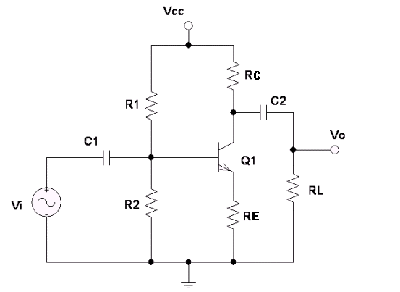

3.1. Second level epigraph
Text of the article…
3.1.1. Third level epigraph
Text of the article…
4. DISCUSSION and CONCLUsIONS
Interpretation of the results achieved by the study regarding to what other authors have found of the topic. It is about explaining what the results mean, taking into account the available evidences. Furthermore, potential limitations of the study must be included so as future investigation lines.
5. LINKS
Different resources linked with the research (video; visual resources as infographics, presentations or others; the complete document if it is published in another repository; an URL about the project; etc.). It will be compulsory a LINK to the RESEARCH INSTRUMENTS of data collection in comprehensive version, to ease replies of the research.
You can include information relative to availability in open access of research data, according to open science approach.
6. RESEARCH ETHICS
If it is relevant to your study, in this section you can include information about informed consent statement from people involved in the study and/or ethical approval from the institutional review board statement.
7. FUNDING/ACKNOWLEDGeMENTS
In case of financed projects it is recommended to include the information (“This research was funded by...”) or add “This research received no external funding”.
If it is need some acknowledgements or appreciations, these will be placed here at the end of the article, just before the references. It is not compulsory.
8. REFERENCES
They should be placed as indicated in the APA 7th edition (http://www.apastyle.org/). The DOI or a shortened URL should be included whenever possible.
Journal article:
Surname, A., Surname, A. and Surname, A. (year). Title of the article. Name of the journal, vol. (no.), x-x. https://doi.org/xxxx
Surname, A., Surname, A. and Surname, A. (year). Title of the article. Name of journal, vol (no.), x-x. http://xxxx
Surname, A., Surname, A. and Surname, A. (year). Title of the article. Journal name, no., x-x. http://xxxx
Book in print edition:
Surname, A. (year). Title. Publisher.
Book chapter:
Surname, A., Surname, A. and Surname, A. (year). Chapter title. In Surname, A. (Ed.). Title of the book (pp. xx-xx). Publisher.
Communication:
Surname, A., Surname, A., Surname, A. and Surname, A. (year, month). Title of the communication Title of the congress, city, country. http://xxxx
Legal text:
Title law (Additional information, date including years, month and day). Name of the publication, Number of the publication, Date of the publication (in the following order: year, day and month).

INFORMATION ABOUT THE AUTHORS

Name and surname of the author (Bold, arial 10 Pts.)
Institution/work centre (arial, 10 Pts.)

Description of every author (Arial 9 Pts.) Maximum 150 words

The texts published in this journal are subjected under a Attibution-Non Commercial-ShareAlike 4.0 Spain. You can copy them, distribute them, communicate them publicly and make derivated work as long as it recognizes work credits (authorship, journal’s name, publishing institution) in the specified way by the authors or by the journal. The complete license can be checked on: Attribution-NonCommercial-ShareAlike 4.0 International (CC BY-NC-SA 4.0).

