The Entrepreneurial Credibility Model on students from nursing and physiotherapy.

Mussons-Torras, Marc¹
Tarrats-Pons, Elisenda²

¹ Universidad de Vic – Universidad Central de Cataluña
PdH from UPC. Orcid: 0000-0001-7972-8149
Rectorado. Edificio A. Carrer de Miramarges, 4, 08500 Vic, Barcelona
938815501 – 687473043 marc.mussons@uvic.cat

² Universidad de Vic – Universidad Central de Cataluña
PdH from UPC. Professor and Director of the Department of the Faculty of Business and Communication

Abstract:

Objective:
This paper analyses social and demographic factors, personality traits and the endogenous and exogenous variables of feasibility in order to find out the ones that generate the greatest influence on the entrepreneurial behaviour from physiotherapy and nursing students.

Method:
The study is based on the Krueger and Brazeal model of entrepreneurial potential, which is a mix of the Shapero’s model of the entrepreneurial event, and the Ajzen’s theory of planned behaviour.
The research identifies the key variables of perceived desirability and feasibility on the entrepreneur student credibility. The data were collected from 302 students of health science degrees: nursing (122); physiotherapy (180).

Results:
The equation model of the credibility on entrepreneurship shows the importance of the feasibility perception, especially on innovation and creativity, and self- efficacy. The model also includes the variables of effort and perseverance, unemployment and funding.

Conclusion:
The educative programs on entrepreneurship are effective when they impact to personality traits as openness, propensity to risk, responsibility and need of achievement. This is because each one of them affects directly to the variable key of creativity and innovation.
The study confirms that physiotherapy students are more likely to become entrepreneurs than nursing students are.

Keywords:
Entrepreneurship Credibility; Self-Efficacy; Creativity and Innovation; Effort and Perseverance; Unemployment; Funding.

Introduction

The Bolonga Process ⁽¹⁾, stablishes a new universitarial frame for the graduates to deal with the demand of an increasing working market more globalised and demanding, where investigation oriented to innovation must be the key to reassure an economic and sustainable growth for the European Union.
The Union for innovation embraces guidelines and political framework from the European Commission to avoid the recession, focused on promoting the entrepreneurship, supporting young and innovative companies, strengthening the bonds between education, business, investigation and innovation. The European Comission, in the Europa 2020 strategy, and in line with the Bolonga Declaration and the Lisboa’s strategy, reinforce the cooperation between university and business, through the construction of I+D+i bridges, that foments an intelligent growth based on innovation and knowledge.
One of the fundamental aspects for the university to successfully adapt to the new society of knowledge is that the same university must promote new roles and new training activities. Amongst them, we outline the encouragement of the entrepreneur spirit and knowledge transference, the continuous training and innovation, and the creation of stronger bonds between university and businesses, which will make the university lead new successful transformations that suppose a bigger economic, social and cultural impact ⁽²⁾.
Analysing the entrepreneur competence of our university students will be key given that the future entrepreneurs will have to innovate through knowledge.
The invigorating axis of the new economy has its origin on the triple helix model of Etzkowitz ⁽³⁾, which stablishes bonds between university, business and the public sector. The European commission adopts that model and adds specific funds called RIS3 (Research Innovation Smart Specialisation Strategies).
That is why the entrepreneur act becomes an essential and strategic element.
The key element of the whole entrepreneurship process is the intention that implies the voluntary and conscious decision to become an entrepreneur ⁽⁴⁾. It is the best predictor of the future entrepreneur behaviour ^{(5,6)}.
The analysis of the entrepreneur intention is determining to explain the business creation. Many authors have developed empiric investigations trying to obtain the key elements that influence the subject through the cognitive approach.
The entrepreneurship models have their origin on the cognitive approach, which interprets that anything we do or we decide as human beings is directly influenced by mental processes such as motivation, perceptions or attitudes ⁽⁷⁾. That is why the first studies about entrepreneurship were focused on motivation, which is one of the key reasons to decide to create a new business ⁽⁸⁾. The entrepreneurship intention studies, according to the cognitive approach, starts on the theory of social learning, which outlines the environment influence and the society on the entrepreneurship ⁽⁸⁾.
The same author defines self-efficacy as the perception control on performance working activity. As we will see later, it is a significant variable on the results of our investigation.
Another entrepreneurship intention model is from Shapero and Sokol ⁽¹⁰⁾. According to this model, the subject’s election to create a new business depends solely on three group of elements: desirability and feasibility perception and propensity to act. Where the feasibility perception refers to the conscious skill of the individual to develop successfully the entrepreneur behaviour, equivalent to the self-efficacy concept of Bandura.
According to Shapero ⁽¹⁰⁾, the subject will always choose a believable behaviour. Meaning that the believable option comes from the positive combination between desire and feas.
These perceptions explain mostly the entrepreneurship intention of the subject, even though it is always on a potential level. That potential needs significant and crucial events on the subject’s life for him or her to finally decide to become an entrepreneur. Shapero ⁽¹⁰⁾ offers a multitude of examples of businesses funded on special circumstances such as when the entrepreneur loses his previous job and receives a lottery prize, or any other personal change that can trigger the trigger event.
Ajzen’s model (5) about entrepreneurship intention is based on the theory of planned behaviour (TPB), where it suggests that human behaviour require a certain amount of planning, which is influenced by beliefs. These beliefs affect directly to the intention, planned on two factors, the attitude towards action and the subjective rules. Both refer to desirability and are the equivalent to the concept of desirability perception mentioned by Shapero and Sokol (10). The TPB model has a third factor called perceived conduction control, which is the equivalent to Shapero’s and Sokol concept of feasibility perception (10) and self-efficacy of Bandura (11).
Finally Krueger and Brazeal (12) complement Shapero’s and Sokol (10) adding aspects of Ajzen and naming it the entrepreneur potential model, where all the feasibility and desirability perceptions concept are integrated, also the propensity to act and the trigger event. It is important to outline that the entrepreneur potential model (figure 1) comes from the evolution of the previously models.
In this model we outline the relation between the desirability and feasibility perception as key factors of the entrepreneur credibility. Desirability perception is defined as the most or least attractive for the subject when they want to start a new business. These personal attitudes will result in new results. On the belief of possible results factors of the personality of the subject will inflict an influence.
Feasibility perception is understood as the degree in which the subject feels capable of going through on the entrepreneur venture. This feeling comes from the perception of intern control, but it also is the perception of their own capacity of funding the project, having the proper information, feeling capable of overpassing the risks, and having the uncertainty under control. The subject assures with enough anticipation the feasibility of the entrepreneur project, understanding self-efficacy as the cognitive capacity which allows the subject to feel capable to have and get the necessary resources to take control at any situation (11).
One of the effects of self-efficacy perception is that the subject chooses every time his behaviour. The subjects usually avoid these situations that cannot control. In addition, the subjects tend to seek the situation that believe that can control better (11). Moreover and more importantly, the people choose their professional path according to what they feel capable enough and competent. For which we can say or deduct at least inside the theoretical frame that if we are capable to prepare the future students in the creation of their future business we will increment also the intention to become entrepreneurs, which is especially relevant to physiotherapy students, which seem much more oriented to the creation of their own business.

Figure nº1: Theoretical model of the entrepreneur potential (12)

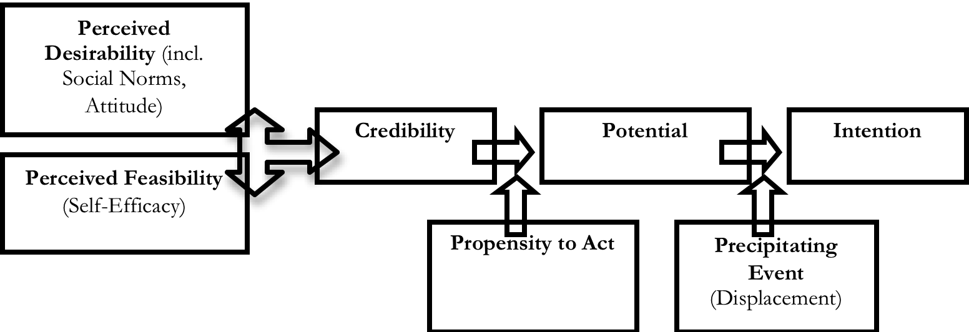

Method

The investigation aims to find out the entrepreneurship credibility model of nursery and physiotherapy students, through the following phases:
Pilot test: to verify the content and construct validity of the instrument and their reliability.
Definitive phase: obtaining the multiple regression equation of the entrepreneurship credibility model and the contrast of the null hypothesis (Ho: Nursery students in relation to the physiotherapy students have a similar level of entrepreneurship credibility).
The data treatment was made through the statistic software SPSS in their 22.0.0 version.

Pilot test

The questionnaire was built ad-hoc, using items coming from scientific investigations of most relevant authors.
The dependent variable known as entrepreneur credibility is created by items based on the attitude scale of entrepreneurship orientation of the authors Robinson, Stimpson and Huefner (13), being also used by Singh and DeNoble (14) (ítems 7,9 and 11).
The independent variables are grouped in the dimensions of desirability and feasibility.
The desirability perception includes social-demographic factors such as age, gender, family background, previous work experience, formation in business courses, and personality traits as neuroticism, extraversion, openness, agreeableness, conscientiousness, self-esteem, self-monitoring, risk propensity, need of achievement and locus control. In feasibility perception, the exogenous economic factors include economic cycle, funding and unemployment. And the personal endogenous factors include creativity and innovation, effort and perseverance, and self-efficacy.

Content validity

The content validity determines if the measuring instrument is used to measure the behaviour intended to be measured. For this reason, the dimensions construction items were previously used and contrasted by other authors. On the other hand, the expert judgements from the Universidad de Vic – Universidad Central de Cataluña reviewed one to one the items. According to the authors Skjong and Wentworth (15), the criterion that an expert should have is expertise and experience in judgement. But It is also important his objectivity, his impartiality and his good reputation in his community.
The trials concluded that most of the items were proper and well written. Only some of the new items needed some correction, especially in comprehension and simplification by avoiding the double negative, for example.

Construct validity

To determine the construct validity and the reliability indexes of the instrument, the pilot test was made on 84 student’s sample. The statistic method used was randomized for conglomerates in a natural form, where a sample unit is a group of elements of the population that create a unit (specifically, the day of the programme Aracoop Empren en clau Coop, developed on the UVIC-UCC on September 2015). The data obtained for each dimension was factorially analysed through the extraction of components with Varimax rotation. In each group of items that explain the variable or dimension, it is determined if all the items are properly correlated to their dimension.
As a general criterion, George and Mallery (16) consider reliable coefficient the alpha Cronbach superior to 5. Being the range of five and six enough (but poor). In our case, a variable beneath five is effort and perseverance. That would indicate the student analysis for this factor, has to be made cautiously, and evaluating the results knowing that can be not entirely reliable. For the rest, once the propensity to act is eliminated, it would indicate that we have a reliable questionnaire which results can be analysed assuming the content validity and construct of the form.

Definitive phase

The sample consists on 302 students of the degree in nursing (40,4%) and physiotherapy (59,6%), obtained on 2015. Which 88% are under 25 years old and the 63% are women. Moreover, 55% have some business family background, 69% have previous work experience and 23% have had some business creation training.
The statistics technique to find the equation that allows measuring and predicting the entrepreneurship credibility of the students on health degrees is the multiple linear regression, once guaranteed the following statements:
- Linearity: it is rejected the null hypothesis that the values have no lineal relation with the dependent variable (F=69,648; prob 0,000).
-Normality: the regression of the standardized residue in relation with the dependent variable draws a normal distribution graphic (figure 2), also the diagonal alignment of the standardized residue (figure 3).

Figure nº2: Histogram of standardized residue

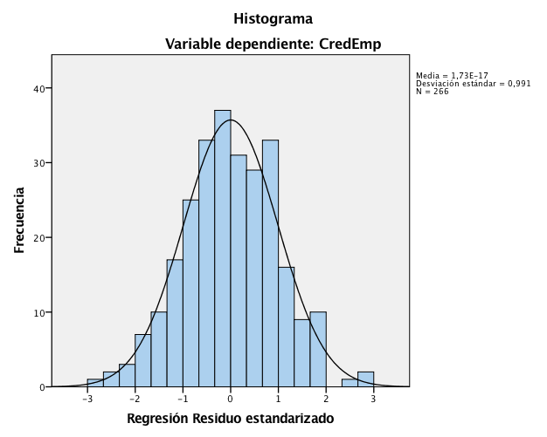

Figure nº3: Standardized regression residue
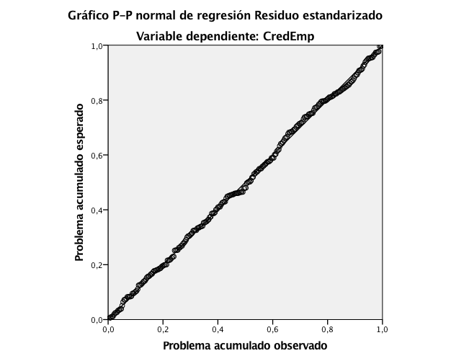

- Independence of residues: is met, if they are random and independent, being the statistic Durbin Watson near 2 (=1,833).
- Homoscedasticity: the variation of residues is constant for each combination of the independent variable in relation to the dependent one. Observing that there is a dot cloud and no correlation between standardized residues and predicted values (figure 4).

Figure nº4: Dispersion diagram of standardized residue

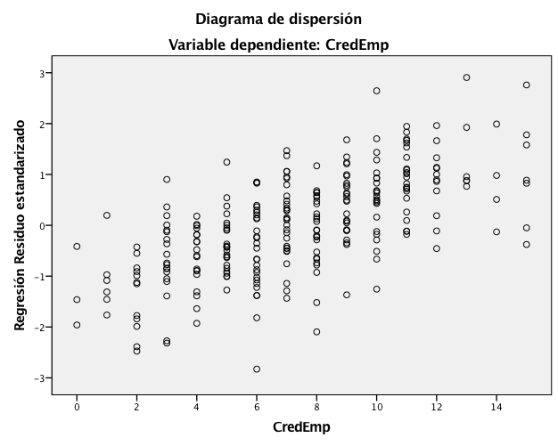

- Non-collinearity: it is met, if there is no lineal relation between any of the independent variables. In our case, all the tolerance values are between, 704 and, 848; and inflation factors of the variation (FIV) between 1,309 and 1,420 (chart 1)

Chart nº1: Collinearity statistics of the model

Variables | Tolerance | VIF
Self-efficacy | 0,704 | 1,42
Creativity and innovation | 0,848 | 1,18
Effort and perseverance | 0,718 | 1,393
Unemployment | 0,747 | 1,339
Funding | 0,764 | 1,309
VIF: inflation factor of the variability. Dependent variable: entrepreneurship credibility

The investigation uses the multiple regression technique for successive steps, introducing the variables with greater beta and more significance, to then be able to observe the changes in squared R of the model.

We consider necessary the introduced variable if it meets the following conditions:
*The variation of squared R is superior than 0,01.
*The condition index is 10-20, showing little collinearity ⁽¹⁷⁾.
*The inflation factor of the variable (FIV) is under 10 in all the variables⁽¹⁸⁾
In chart 2 we see that while more variables are added, the explanation of the variable increases. It is important to outline the great importance that the first added variable adopts. Self-efficacy explains the 40,2% of the variation of the whole variable of the dependent variable of entrepreneurship credibility.

The requisites of non-collinearity of the condition index and the FIV met. For the five dimensions of the model the index condition is on 12,944 (chart 3), and with only two variable combinations with a bigger variation proportion. While the FIV variables does not overpass 1,42 (chart 1).

Chart nº2: Construction of the entrepreneurship credibility model

Models | R | Squared R | Adjusted squared R | Estimation standarized error | Squared R change
1 | ,634 | 0,402 | 0,4 | 2,645 | 0,402
2 | ,695 | 0,483 | 0,479 | 2,465 | 0,08
3 | ,730 | 0,532 | 0,527 | 2,349 | 0,049
4 | ,750 | 0,563 | 0,556 | 2,276 | 0,03
5 | ,757 | 0,573 | 0,564 | 2,255 | 0,01
Model: 1: constant + self-efficacy; 2: constant + self-efficacy + creativity and innovation; 3: constant + constant + self-efficacy + creativity and innovation + effort and perseverance; 4: constant + constant + self-efficacy + creativity and innovation + effort and perseverance + unemployment; 5: constant + constant + self-efficacy + creativity and innovation + effort and perseverance + unemployment + funding

Chart nº3: Collinearity diagnosis

Dimension | Self-value | Condition index
1 | 5,36 | 1
2 | 0,338 | 3,982
3 | 0,102 | 7,256
4 | 0,097 | 7,415
5 | 0,07 | 8,731
6 | 0,032 | 12,944
Dependent variable: entrepreneurship credibility

Chart nº4: Variation proportion

Constant | Self-efficacy | Creativity and innovation | Effort and perseverance | Unemployment | Funding
0 | 0 | 0 | 0 | 0,01 | 0
0,01 | 0 | 0,01 | 0,01 | 0,79 | 0
0,01 | 0,61 | 0,09 | 0,11 | 0,15 | 0,13
0,02 | 0,28 | 0 | 0,23 | 0 | 0,52
0,1 | 0,09 | 0,14 | 0,62 | 0,05 | 0,27
0,86 | 0,01 | 0,76 | 0,03 | 0,01 | 0,08
Dependent variable: entrepreneurship credibility

Results

The resulting equation of entrepreneurship credibility is (chart 5):

Entrepreneurship credibility = -1,75 + 0,53 Self-efficacy + 0,43 Creativity and innovation + 0,41 Effort and perseverance+ 0,37 Unemployment + 0,18 Funding

Chart nº5: The entrepreneurship credibility equation

Models | variables | Beta | Standard error
1 | Constant | 2,48 | 0,40
 | Self-efficacy | 0,85 | 0,06
2 | Constant | -0,73 | 0,63
 | Self-efficacy | 0,78 | 0,06
 | Creativity and innovation | 0,61 | 0,10
3 | Constant | -1,23 | 0,60
 | Self-efficacy | 0,66 | 0,06
 | Creativity and innovation | 0,43 | 0,10
 | Effort and perseverance | 0,49 | 0,09
4 | Constante | -1,22 | 0,58
 | Self-efficacy | 0,57 | 0,06
 | Creativity and innovation | 0,44 | 0,09
 | Effort and perseverance | 0,43 | 0,09
 | Unemployment | 0,44 | 0,10
5 | Constant | -1,75 | 0,62
 | Self-efficacy | 0,53 | 0,07
 | Creativity and innovation | 0,43 | 0,09
 | Effort and perseverance | 0,41 | 0,09
 | Unemployment | 0,37 | 0,11
 | Funding | 0,18 | 0,07
Non-standardized coefficients; dependent variable: entrepreneurship credibility.

The entrepreneurship credibility model obtains a great squared R index. The goodness of fit is ,571. That means that the independent variables explain the 57% of the whole entrepreneur’s credibility variation.

That is a significant fact, especially if we compare it to the adjustment values of others entrepreneurship models (chart 6).

Chart nº6: adjustment values of other models

Author | Goodness of fit (squared R)
(Brice, 2002) | 0,07
(Singh & DeNoble, 2003) | 0,18
(Crant, 1996) | 0,3
(Korunka, Frank, Lueger, & Mugler, 2003) | 0,29
(Lounsbury, Gibson, Sundstrom, Wilburn & Loveland, 2004) | 0,42
(Naldi, Nordqvist, Sjöberg, & Wiklund, 2007) | 0,29
(Lee & Tsang, 2001) | 0,32

Our investigation rejects the null hypothesis that nursing students have a similar entrepreneurship credibility level than physiotherapy students (level of significance 0,00). The study indicates that the analysed physiotheraphy students have a different behaviour than nursing students (chart 7).

Chart nº7: Hypothesis Contrast

U de Mann-Whitney | 5872
W de Wilcoxon | 13253
Z | -6,484
Sig. Asymptotic (bilateral) | 0

Moreover, if we observe the descriptive statistic data (chart 8), we can assure that the physiotherapy students have more entrepreneurship values. Specifically, the mean was 8,31, and the standard deviation was 2,993. On the opposite, the nursing students have lower mean (5,91), and higher standard deviation (showing a greater dispersion on the results).

Chart nº8: Descriptive statistics of every degree

Degree |  | Statistics | Standard Error
Nursing | Mean | 5,91 | 0,306
 | 95% of trust interval | 5,3-6,5
 | Cut average 5% | 5,73
 | Median | 5
 | Variation | 11,367
 | Standard Deviation | 3,371
 | Mínimum | 0
 | Máximum | 15
 | Range | 15
 | Interquartile range | 4
Physiotheraphy | Mean | 8,31 | 0,227
 | 95% of trust interval | 7,86-8,76
 | Cut average 5% | 8,34
 | Median | 8
 | Variation | 8,955
 | Standard Deviation | 2,993
 | Mínimum | 0
 | Máximum | 15
 | Range | 15
 | Interquartile range | 4

Discussion

The model’s equation is formed by variables that contribute on the entrepreneurship credibility of the university student. Being the self-efficacy, the control perception on behaviour ⁽⁵⁾. It represents the feasibility perception and the entrepreneurship intention ^{(10,19)}, being the best predictor of good professional performance⁽¹¹⁾, reducing mistakes and problems that might come up during the entrepreneurship process ⁽⁹⁾ . Self-efficacy is a significant and strong variable in relation to the entrepreneurship potential on most of degree students investigations ^{(4,20,22)}.
Creativity and innovation defines itself as the alertness state to new opportunities. The creative and innovative people are able to detect new opportunities that were unnoticed by the rest. For Athayde ⁽²³⁾, creative people are pioneers of innovative behaviour. The correlation between innovation and entrepreneurship is important, being especially strong on the feasibility perception ^{(13,24,25)}. In our study obtains a high Beta (=.43), which indicates a direct influence with the entrepreneurship credibility of the student. This significant data is complemented by analysing the correlation with other variables regarding to creativity and innovation (chart 9). In this sense, need of achievement (Rho=.526) defines the subject’s desire in improving results, and feeling responsible for them. It is a personal desire of competition to the excellence, searching the best way to do the job, and being very important for the subject. In a similar line we find the responsibility variable (Rho=.393), concept related in being diligent, well-organised, persistent and results-oriented ⁽¹⁴⁾. The openness variable (Rho=.380) defines to open people, that tend to be more creative, original and receptive to new experiences; specially in different interests ⁽¹⁴⁾. In fact, originality and creativity are the factors that are most related to entrepreneurship, because they are the prelude of innovation ⁽²³⁾.

Chart nº9: Creativity and innovation correlation (Spearman’s Rho)

Creativity and innovation | Openness | Responsibility | Need of achievement | Propensity to risk
Correlation coefficient | ,380** | ,393** | ,526** | ,388**
Sig. (bilateral) | 0 | 0 | 0 | 0
N | 267 | 271 | 295 | 291
** The correlation is significant in the 0,01 level (bilateral)

The propensity to risk variable is defined as the preference in situations that might come with benefits and rewards in successful cases, but also great consequences in case of failure ⁽²⁶⁾.
The effort and perseverance variable is related with the opportunity cost and goes beyond pure sacrifice in time and money. In reality, starting up an entrepreneur’s project supposes renounce to the possibility of a stable job ⁽¹⁴⁾. Nevertheless, it also implies economic sacrifice. The entrepreneur must compromise financial resources, periodically in tune with the needs of their business project ⁽²⁷⁾. In the studies with university students, the effort and perseverance variable was confirmed as a key factor in entrepreneurship ^{(14,28)}.
In relation to the unemployment variable, the Veciana marginalization theory ⁽²⁹⁾explains the propensity of people with low job opportunities to become entrepreneurs. Confirms the existing relation between unemployment and entrepreneurship by need ^{(21,28)}. This positive correlation confirms our model, where greater unemployment levels create greater entrepreneurship credibility, even though it is for need or self-employment.
The funding variable, specifically the lack of funding and access to credit, it is perceived for the subject as an obstacle in their feasibility perception of the entrepreneur’s project ^{(28,30)}. The yearly reports of the Global Entrepreneurship Monitor confirms that in Spain there is a growth on the funding difficulties, with a minor contribution on the seed capital on the entrepreneur activity and with a greater need of external funding, especially since 2008.

Conclusions

Along the investigation, we have analysed different factors that influence the possibility that a health student ends up being an entrepreneur. Our starting point on a theoretical level has been framed under the entrepreneurship potential model of Krueger and Brazeal (12). As we have seen it incorporates a fusion between two great entrepreneurship models of Shapero and Sokol (10) and Ajzen (5), which its origins date back to the eighties and nineties.
The Krueger and Brazeal (12) model establishes the possibility to evaluate students in their entrepreneurship potential, and being the “trigger event” the prelude of the entrepreneurship intention.
It is important to outline that the entrepreneurship potential must have the propensity to act, which makes believable the entrepreneurship conduct.
Nonetheless, our investigation focuses on the analysis of the variables that can affect to the entrepreneurship credibility, and improved by social, economic or politics issues, and by training level. These variables are the combination of desirability and feasibility entrepreneur perceptions. So that, our model is able to detect the combination of the needed factors for the student to have believable entrepreneurship behaviour, able to detect new business opportunities, knowing what needs to be done, being perseverant and willing to invest money and time. The proposed entrepreneur credibility model defines the student’s conduct, believable as long as the subject is creative and innovative. But also is contextualised by external factors that influence directly to their feasibility perception as a high unemployment rate or less accessibility to credit.
The final model has other interesting contributions, as knowing that there are some factors that directly affect to the creativity and innovation.
So if we want more students entrepreneurs, we have to boost their creativity and innovation, and all the variables directly related to that, as openness, responsibility, propensity to risk, and need of achievement.
It is interesting to observe that the variable creativity and innovation is located inside the feasibility perception, and defined as “the search of new market opportunities”. But the variables that influence creativity and innovation are from the desirability perception. So these variables can be modified and incremented by the study plans of the physiotherapy and nursing degrees.
The conclusion of the study indicates that there are a few variables that really impact to the future entrepreneurship behaviour, having a major weight the ones relative to the feasibility perception and especially the ones related to self-efficacy, innovation and creativity.
Finally, it is also significant the conclusion that physiotherapy students are more entrepreneurs than nursing students. Even though both groups are created under the same frame of knowledge, their professions are very different once they finish their studies.

References

1. Eurostat. Eurostat statistical book. Publications_Office, editor. European Union; 2009.
2. Reichert S. Institutional diversity in European higher education. Zurich: European University Association; 2009.
3. Etzkowitz H, Leydesdorff L. The triple helix as a model for innovation studies. Sci public policy. 1998;
4. Krueger NF, Reilly MD, Carsrud AL. Competing models of entrepreneurial intentions. J Bus Ventur. 2000;15(5-6):411–32.
5. Ajzen I. The theory of planned behavior. Organ Behav Hum Decis Process. 1991;50:179–211.
6. Kolvereid L. Prediction of employment status choice intentions. Entrep Theory Pract. 1996;21(1):47–57.
7. Krueger NF. The impact of prior entrepreneurial exposure on perceptions of new venture feasibility and desirability. Entrep Theory Pract. 1993;18(1):5–21.
8. Shane S, Locke EA, Collins CJ. Entrepreneurial motivation. Hum Resour Manag Rev. 2003;257-279.
9. Bandura A. The Social Foundations of Thought and Action. Prentice-Hall, editor. Englewood Cliffs, NJ.; 1986.
10. Shapero A, Sokol L. The social dimension of entrepreneurship. Prentice H. Kent CA, Sexton DL, Vesper KH, editors. The encyclopedia of entrepreneurship. Englewood Cliffs, NJ.; 1982. 72-90 p.
11. Wood R, Bandura A. Social cognitive theory of organizational management. Acad Manag Rev. 1989;14:361–84.
12. Krueger Jr NF, Brazeal D V. Entrepreneurial Potential and Potential Entrepreneurs. Entrepreneurship Theory and Practice. 1994;91–104.
13. Robinson PB, Stimpson D V, Huefner JC, Hunt HK. An attitude approach to the prediction of entrepreneurship. Entrep Theory Pract. 1991;15(4):13–31.
14. Singh G, DeNoble A. Views on self-employment and personality: an exploratory study. J Dev Entrep. 2003;8(3):265–81.
15. Skjong R, Wentworth B. Expert Judgement and risk perception. Det Nor Verit. 2000;
16. George D, Mallery P. SPSS for Windows step by step: a Simple Guide and Reference. 4th ed. Bacon A&, editor. Boston; 2003.
17. Belsley DA. Conditioning diagnostics: collinearity and weak data in regression. In: John Wiley & Sons I, editor. 1991.
18. Neter J, Wasserman W, Kutner MH. Applied Linear Statistical Models. M.A: Irwin. 1990.
19. Krueger NF, Carsrud AL. Entrepreneurial intentions: applying the theory of planned behavior. Entrep Reg Dev. 1993;5(4):315–30.
20. Chen CC, Greene PG, Crick A. Does entrepreneurial self-efficacy distinguish entrepreneurs from managers? J Bus Ventur. 1998;13:295–316.
21. Linan F, Urbano D, Guerrero M. Regional variations in entrepreneurial cognitions: Start-up intentions of university students in Spain. Entrep Reg Dev. 2011;23(3-4).
22. Liñán F, Chen Y-W. Development and Cross-Cultural Application of a Specific Instrument to Measure Entrepeneurial Intentions. Entrep Theory Pract. 2009;593–617.
23. Athayde R. Measuring Enterprise Potential in Young People. Entrep Theory Pract. 2009;481–500.
24. Ismail N, Jaffar N, Siow T. Using EAO model to predict the self-employment intentions among the Universities’ Undergraduates in Malaysia. Int J Trade, Econ Financ. 2013;4:282–7.
25. Wang W, Lu W, Millington JK. Determinants of Entrepreneurial Intention among College Students in China and USA. J Glob Entrep Res. 2011;1(1):35–44.
26. Brockhaus RH. Risk taking propensity of entrepreneurs. Acad Manag J. 1980;23(3):509–20.
27. Hisrich R, Peters M. Entrepreneurship. Vol. 5. Nueva York: Mc Graw Hill; 2002.
28. Espí MT, Arana G, Heras I, Diaz A. Perfil emprendedor del alumnado universitario del campus de Gipuzkoa de la Upv/Ehu. Rev Dir y Adm Empres. 2007;14:83–110.
29. Veciana JM. Creación de empresas como programa de investigación científica. Rev Eur Dir y Econ la Empres. 1999;8(3):11–36.
30. Lüthje C, Franke N. The “making” of an entrepreneur: testing a model of entrepreneurial intent among engineering students at MIT. R&D Manag. 2003;33(2):135–47.

