Effectiveness of preoperative visit on anxiety, pain and wellbeing
ABSTRACT
Objective: Assess whether the preoperative visit is an effective instrument to reduce both the preoperative anxiety level and postoperative pain.
Methods: Randomized controlled trial with two groups, repeated measures before-after. The study consists of comparing the average levels of anxiety, pain and well-being at different times of the surgical process. The non-parametric tests of U Mann-Whitney and Chi-Square Pearson were used for the bivariate analysis and Spearmans’s Rho correlation was used to check the association between quantitative variables
Results: The experimental group shows a statistically significant decrease of the preoperative anxiety level and postoperative pain and an increase of wellbeing
Conclusions: The preoperative visit is an effective instrument to reduce the situational anxiety level and postoperative pain.
Keywords: Preoperative visit, anxiety, elective surgery, well-being, Caring.

TEXT
Introduction
The person who is going to have surgery becomes part of a completely unknown system that could imply certain risks^{1, 2}. This experience could cause, to a certain extent, some reactions or manifestations such as insecurity, fear, agitation and anxiety²⁻⁵. If stress and anxiety exceed the expected limits, it could lead to the negative aspects of anxiety⁶. Many researches have proved that as much intense is the preoperative anxiety, longer and more difficult could be the convalescence, increasing the perception of postoperative pain and consequently, influencing on the wellbeing of the person ^{2,6-15}.
This situation is aggravated by the fact of being immerse in a hostile environment due to the structure or organization of the operating room: cold, aseptic, highly technologized, full of alarms, sophisticated devices and powerful lights¹⁶. Furthermore, the situation is even worse when the patient is having surgery with loco regional anesthesia¹⁷⁻¹⁹. All these circumstances that the surgery involves may be perceived as a threat by the patient, what could cause him a feeling of anxiety.
The surgical fact does not only affect the patient physically and psychologically, but socially and spiritually, if we analyze it from a holistic point of view ^{7,16,20-23}. Jean Watson and his theory of Caring ²⁴⁻²⁷ is a reference on the holistic and human care. Watson states that “…both nurse training and the caregiving system must be based on human values and must care for others’ wellbeing…”²⁸. The idea of caring is to relieve human pain by creating a relationship characterized by the responsibility and the wish to do well and promote health and life. During the preoperative and perioperative the idea of caring gives the nurse the possibility to create a relationship with the patients and they see the nurse as “someone who creates a calm environment, who takes care of them and someone who they can trust”²⁹.
Through communication and dialogue the nurse encourages the patients to verbalize and show their feelings and fears³⁰, as well as she shows her willingness to listen carefully and respectfully. Thus, she can identify their needs, perceive their anxiety, doubts and fears, and provide a better help and support during the surgical process. At this point, the role of the nurse is much more important as they offer a direct and quality attention.
In order to achieve positive results to control the anxiety and improve the wellbeing of the patients, it is essential to give as much information as possible. Another effective measure is caring out the preoperative visit during the preoperative process.
Pre-operative visit is understood as the process of personalizing the care between the nurse and the patient before a programmed surgery. It is done by carrying a personalized meeting aimed to provide information, advice, self care knowledge and, thus, to reduce the anxiety and fear¹. It must be taken into account that a surgical operation is not only affecting the patient but a whole family³⁰, that is why family must also be taken under consideration while carrying out a preoperative visit.
Among the studies on this subject there is controversy over the effectiveness of the preoperative visit reducing the anxiety levels. Back in the 60’s a study by Egbert et al.³¹ proved that the information was much more effective to reduce the preoperative anxiety than sedation. As years went by, more and more studies have become to prove so especially in the last decade when this subject has been studied the most ^{6,7-9,19,32-43}.
On one hand, the studies by Chiriviches et al.⁷, Aparcero et al.⁴ and Orihuela-Pérez et al.¹ prove that those patients who received additional information about the surgical process through a structured pre-operative visit have statistically significant lower levels of stationary anxiety. However, one the other hand, the studies by Díez-Álvarez et al.³³, Marín Romero et al.²⁰ and Navas⁴⁴ state that the anxiety decrease after receiving additional information is not statistically significant.
Other studies are focused on the moment when the patient starts experiencing an increase of the anxiety levels. Some studies affirm that anxiety appears at least one week before the surgery, and that intensifies in the hours before admission, what means that it would be much better to give the pre-operative information before patients are admitted to the hospital ^{2,6,19,34,44,45}.
Some authors, as Herrera-Espiñeira et al.⁴⁶ and Kindler⁴⁷, even state that the cultural level and the age are related to the information comprehension.
Although the controversy among studies about the effectiveness of the preoperative visit on anxiety and pain, many of the authors agree that information and education provided during the preoperative visit improves the perception of satisfaction and wellbeing^{1,4,7,10,37,38,43,48-50}.

Objective
The aim of this study was to analyze the effect of a structured preoperative nursing visit on the anxiety levels, post-operative pain and wellbeing during the surgical process. Additionally, it was studied if there was any association between anxiety levels and pain, as well as the previous surgery experiences and the accuracy of the received information.

Methods
Randomized controlled trial with two groups, repeated measures before-after.
The sample population was made up by 30 patients in each group, whose hospitalization was scheduled in the hospital unit of Traumatology and Orthopedics Surgical Service in Hospital Sant Pau i Santa Tecla de Tarragona. They were operated on for Total Knee Prosthesis (TKP), Total Hip Prosthesis (THP) and Lumbar Arthrodesis (LA). Patients under 18, patients with any cognitive deterioration, psychiatric patients and foreigners who weren’t able to understand any of both official languages in Catalonia (Catalan or Spanish) and oncologic patients (whose anxiety is intrinsic to this process and their levels of anxiety could modify the results of the study) were excluded of the project. The patients were admitted consecutively from January to March 2012.
Committee for Ethical Clinical Investigation of Hospital de Tarragona Joan XXIII approved the study protocol in 4th January 2012 (ref. CEIC 61/2011) and the Scientific Advisory Committee of Hospital Sant Pau i Santa Tecla de Tarragona authorized the study.
The STAI (State-Trait Anxiety Inventory) questionnaire was used as an instrument to obtain some data. State-Anxiety (S/A) can be defined as a state or temporary emotional condition experienced in a certain time. Trait-Anxiety (T/A) is an anxiety pattern that characterizes a personality trait⁵¹. The S/A scale has 20 questions asking the patients about the feelings at that moment and the possible answers are: not at all 0, somewhat 1, moderately so 2, very much so 3. The T/A scale has 20 questions asking them about how do they feel generally and the possible answers are: almost never 0, sometimes 1, often 2 and almost always 3. In both questionnaires the questions are asked on a direct or indirect scale and they are mixed in order to avoid acquiescence. The total score varies between 0 and 60 that become percentiles depending on the gender and age. Item 20 in the S/A questionnaire was highlighted to obtain the score of the wellbeing perception. Visual Analogue Scale (VAS) was used to measure the pain. Other socio-demographic variables as the age, gender, civil status, studies and previous surgeries were taken into account.
At the time of admission, the afternoon before the surgery, the patients of both groups (control group and experimental group) were given standardized information about the service. They were informed by a nurse of the traumatology unit. Afterwards, a scrub nurse visited the patients of both groups and informed them with a written document about the aim of the study and asked them to sign the consent form. Additionally, the patients in the experimental group received the specific information of the preoperative visit.

The data was collected at different times of the process: the admission day, once in the preoperative anesthetic room, during the first 72 hours after surgery (Table I).

TABLE I. Data collection Schedule.
CONTROL GROUP n=30 |  |  | SURGERY GROUP n=30
DAY | PLACE | DOCUMENTS | DAY | PLACE | DOCUMENTS
1st day | Hospital room | -Information about study | 1st day | Hospital room | -Information about study
Admission 6 p.m. | Hospital room | -Consent form signature | Admission 6 p.m. | Hospital room | -Consent form signature
 | Hospital room | -STAI test S/A + T/A admission | INFORMATION | Hospital room | -STAI test S/A + T/A admission
 | Hospital room | -Socio-demographic data | PREOPERATIVE VISIT | Hospital room | -Socio-demographic data
2nd day | Pre-op anesthetic room | -STAI test S/A pre-op. | 2nd day | Pre-op anesthetic room | -STAI test S/A pre-op.
Surgery | Recovery room discharge | -VAS pain recovery discharge | Surgery | Recovery room discharge | -VAS pain recovery discharge
3rd day | Clinical course consult | -VAS pain post 24 h. | 3rd day | Clinical course consult | -VAS pain post 24 h.
4th day | Clinical course consult | - VAS pain post 48 h. | 4th day | Clinical course consult | -VAS pain post 48 h.
5th day | Hospital room | - STAI test S/A post 72h | 5th day | Hospital room | -STAI test S/A post 72h
5th day | Hospital room | - VAS pain post 72h | 5th day | Hospital room | -VAS pain post 72h
Table I: Data colletcion Schedule.

SPSS Statistics 17.0 system for Windows was used for the data analysis. The categorical variables (socio-demographic data) were described with rates and percentages, whereas the quantity variables (anxiety, pain, well-being, information) were described with arithmetic mean and standard deviation.
Subsequently Kolmogorov-Smirnov test was used to test the normality of the quantity variables distribution. As a normal distribution was not obtained, it was decided to continue the bivariate analysis with the non-parametric test.
Pearson's Chi-squared test was used to check if there was any relation between categorical variables and the groups (control or experimental group). Mann-Whitney U test for independent samples was used to check the quantity variables (percentiles of state-anxiety and VAS pain scale) and the ordinal categorical variables (wellbeing). Subsequently we compared the state-anxiety levels with the experience in previous surgeries (positive or negative) and the information received (sufficient or insufficient).

Spearman’s Rho correlation was used to see if there was any relation between the state-anxiety levels and the pain.
95% confidence intervals were calculated with a significance level of p<0.05.

Results
The average age of the control group patients was 67’87 years (SD=12’7) with an age range of 33 to 83, whereas in the experimental group the average age was 67’40 years (SD=11’73) with an age range of 42 to 81 years.
The surgeries carried out were similar in both groups. Control group: lumbar arthrodesis (20%), total knee prosthesis (56,7%) and total hip prosthesis (23,3%). Experimental group: lumbar arthrodesis (26,7%), total knee prosthesis (50%) and total hip prosthesis (23,3%). We have to highlight the fact that the patients in the control group were mostly women (80%) while in the experimental group it was more balanced (56,7%).
To analyze the state-anxiety levels during the whole process we calculated the difference between different moments and the most significant one was the difference between the time of admission (one day prior the surgery) and the time in the pre-op anesthetic room (just before going into the surgery room). As it can be observed in graphic 1, the control group experienced an increase of the anxiety level (15.83 points), whereas in the experimental group, the anxiety decreased (3.03 points), making the difference of the evolution between both groups statistically significant (p=0,001).

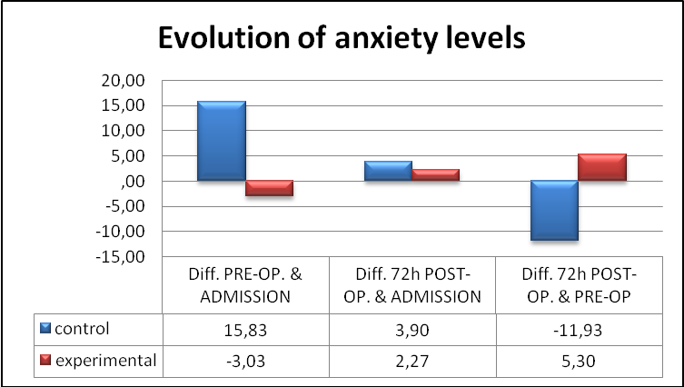
Graphic 1: Evolution of anxiety levels in different times of the process (CI 95%).

Graphic 2 shows the evolution of the pain perception according to Visual Analogue Scale (VAS). It is observed that the control group had a higher VAS than the experimental group in all four phases of the process.
This difference was statistically significant at the 24, 48 and 72 postoperative hours with an associated p-value lower than 0.05 (p=0.043, 0.001 y 0.017 respectively).

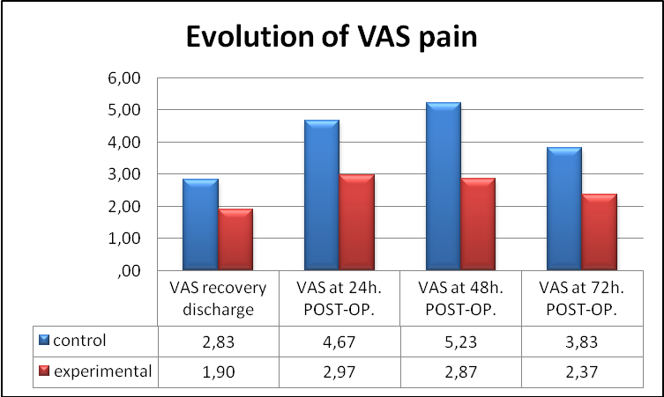
Graphic 2: Evaluation of pain perception at the different phases of the process.

Afterwards we compared the state-anxiety levels with the previous surgery experiences, taking into account whether they were positive or negative experiences. Graphic 3 shows how patients who had positives previous experiences had lower levels of anxiety than those patients who had had negative experiences. This was a statistically significant difference with p-values lower than 0.05 (p=0.046, 0.017 and 0.005 respectively).

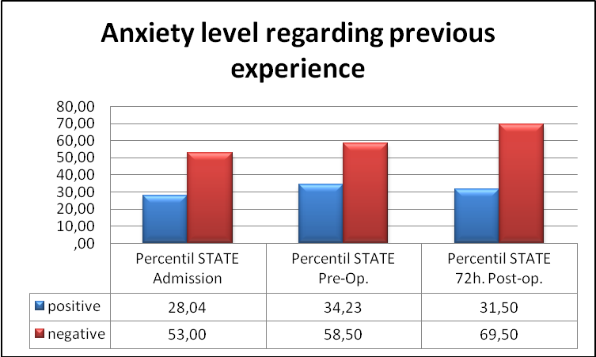
Graphic 3: Anxiety levels regarding previous experience.

When patients were asked about the sufficiency of the information received, the group that considered it sufficient showed to have a statistically lower lever of state-anxiety than the group that considered it insufficient (p=0.039) at the admission time.
In regard to the evolution of the wellbeing perception there are significant differences between the groups: the experimental group answered a higher number of “moderately so” and “very much so” than the control group when they were in the preanesthesia room (p<0.001) and at the postoperative 72 hour (p=0,001). By contrast, the only “not at all” scores where answered by the control group at the same situations.
Regarding the possible relation between the state-anxiety and the pain perception, the Spearman’s Rho coefficients ranged between 0.310 and 0.661. That means a positive association from moderate to substantial between the state-anxiety levels at the admission time and the preanesthetic phase (p=0.661) and at the postoperative 72 hour (p=0.599). It must be emphasized the moderate positive relation between the state-anxiety levels at the preanesthetic phase and the postoperative pain at the subsequent 24 hours (p=0.344), 48 hours (p=0.499) and 72 hours (p=0.463).
Discussion and conclusion
This study proves that those people who have a high level of state-anxiety at the admission time, would experience an increase of anxiety at the preanesthesia room and, consequently, they would have a perception of the pain significantly greater during the 24, 48 and 72 postoperative hours.
These results are at the same line as other studies that evaluate the importance of the information given prior to the surgery^{31,37,42} and the effectiveness of an structured preoperative nursing visit to reduce both preoperative anxiety and the perception of postoperative pain during the first 72 hours^{1,4,7}.
As the studies of Heluy et al.³⁰ and Balaguer⁵, we have also consider the family as an important element of the process and they have been encouraged to be present and ask all their doubts during the preoperative visit. In some cases, the attitude of the family was essential. Since some of the older or uneducated patients had shown their concern about taking part of this project, the willingness of the family made easier the data collection.
The wellbeing perception, described in the Caring theory by Jean Watson, improved significantly in all those patients who received special information during the preoperative visit. It improved specially during the preanesthetic time and during the 72 postoperative hours , with similar results as other published studies^{1,4,7,10,37,38,43,48-50}.
Unlike the statements of Kindler et al.⁴⁷ and Herrera-Espiñeira et al.⁴⁶, education level didn’t statistically influenced on the levels of anxiety or the postoperative pain perception, though all the uneducated patients had higher scores.

Due to the improvements on surgical and anesthetic techniques in the last years, the days of hospitalization has been reduced. However, there has also been an increase of Major Ambulatory Surgery (MAS) and Minimally Invasive Surgery (MIS) in which the patient is admitted the same day of the surgery^{12,52}. Paradoxically, all these improvements reduce the possibility of carring out a preoperative visit the day before the surgery what means a less contact between nurse and patient and a lower possibility of giving all the necessary information in order to reduce anxiety.
As conclusion of this study, the results prove that a structured preoperative nursing visit is an effective instrument to reduce anxiety prior to surgery and postoperative pain during the first 72 hours, as well as to improve the wellbeing perception.
In order to improve and humanize nursing care, the organizational systems must be changed because they no longer meet our society needs⁵³. We must create nurse visits separately than anesthetic visits with the aim to provide a quality care and the benefits and tranquilizer effects of the nurse role during the preoperative process. We must include MAS and MIS patients, who could received the preoperative visit one week before surgery in order to reduce their anxiety, as several studies support^{2,6,19,33,42,43,}.
We propose new lines of investigation with quality methodology to identify personal experiences and special needs for information comprehension with the aim of publishing and spreading the results to contribute in the progress of the discipline of nursing and improve the nursing quality at all levels.

Acknowledgements
We would like to thank Georgina Valls Imbernón for making the English translation of this article.
BIBLIOGRAPHY
1.- Orihuela Pérez I, Aranda Salcedo T, Escobar Julián F, González Ramírez A, Jiménez Ruiz R, Martínez García A, et al. Visita preoperatoria de enfermería: evaluación de la efectividad de la intervención enfermera y percepción del paciente. Enfermería Clínica. 2010;20(6):349-354.
2.- Carapia-Sadurni A, Mejía-Terrazas GE, Nacif-Gobera L, Hernández-Ordóñez MN. Efecto de la intervención psicológica sobre la ansiedad preoperatoria. Revista Mexicana de Anestesiología. 2011;34(4):260-263.
3.- de la Paz-Estrada C, Prego-Beltrán C, Barzaga-Hernández E. Miedo y ansiedad a la anestesia en pacientes sometidos a cirugía. Revista Mexicana de Anestesiología. 2006;29:159-162.
4.- Aparcero Bernet L, Núñez García A, Ramos Fernández M, Zahino Ruiz G, Olcina Santonja R. La visita entrevista prequirúrgica: Intervención de enfermera e instrumento de calidad. Enfuro. 2003(88):9-13.
5.- Balaguer de Dios M. Protocolo de acogida e información preoperatoria para pacientes quirúrgicos. Revista de la Asociación Española de Enfermería Quirúrgica. 2006(22):7-13.
6.- Valenzuela-Millán J, Barrera-Serrano JR, Ornelas-Aguirre JM. Ansiedad preoperatoria en procedimientos anestésicos. Cirugía y Cirujanos. 2010;78(2):151-156
7.- Chirveches E, Arnau A, Soley M, Clotet G, Roura P, et al. Efecto de una visita prequirúrgica de enfermería perioperatoria sobre la ansiedad y el dolor. Enfermería Clínica. 2006;16(1):3-10.
8.- Martín-Crespo Blanco MC, Caravantes Marín MI, García Mas JM, Gómez González B. Efecto de la intervención enfermera durante el intraoperatorio en el grado de ansiedad del paciente quirúrgico en el hospital comarcal Virgen de Altagracia de Manzanares (Ciudad Real). Nure Investigation. 30.
9.- Moix Queraltó J. Disminución de la ansiedad como factor de mejora de la calidad asistencial en pacientes quirúrgicos. Revista de Calidad Asistencial. 1998;13:160-165.
10.- Moix Queraltó J. Emoción y cirugía. Anales de Psicología. 1994;10(2):167-175.
11.- Munafò MR, Stevenson J. Anxiety and surgical recovery: Reinterpreting the literature. Journal of Psychosomatic Research. 2001;51(4):589-596.
12.- McIntosh S, Adams J. Anxiety and quality of recovery in day surgery: A questionnaire study using Hospital Anxiety and Depression Scale and Quality of Recovery Score. International Journal of Nursing Practice. 2011;17(1):85-92.
13.- Caumo W, Schmidt AP, Schneider CN, Bergmann J, Iwamoto CW, Bandeira D, et al. Risk factors for preoperative anxiety in adults. Acta Anaesthesiologica Scandinavica. 2001;45(3):298.
14.- Vaughn F, Wichowski H, Bosworth G. Does preoperative anxiety level predict postoperative pain? AORN Journal. 2007;85(3):589-604.
15.- Kagan I, Bar Tal Y. The effect of preoperative uncertainty and anxiety on short-term recovery after elective arthroplasty. Journal of Clinical Nursing. 2008;17(5):576-83.
16.- Varela Curto MD, Villamisar Ferreiro MJ, Sanjurjo Gómez ML, Lamata Martínez A. Plan estandarizado de cuidados intraoperatorios. Enfuro. 2004(90):25-29.
17.- Mitchell M. Conscious surgery: Influence of the environment on patient anxiety. Journal of advanced Nursing. 2008;64(3):261-271.
18.- Mitchell M. Patient anxiety and conscious surgery. Journal of Perioperative Practice. 2009;19(6):168-173.
19.- Mitchell M. Patient anxiety and modern elective surgery: a literature review. Journal of Clinical Nursing. 2003;12(6):806.
20.- Marín Romero I, Martínez Gómez P, Ponsich Pubill J, Pubill Grasa M. Ansiedad en paciente intervenidos de rodilla (Prótesis Total Rodilla). Enfermería Global. 2004;4:1-11.
21.- Eriksson K. Caring science in a new key. Nursing Science Quarterly. 2002;15(1):61-65.
22.- Fawcett J, Watson J, Neuman B, Walker PH, Fitzpatrick JJ. On nursing theories and evidence. Journal of Nursing Scholarship. 2001;33(2):115-119.
23.- Gordillo León F, Arana Martínez JM, Mestas Hernández L. Tratamiento de la ansiedad en pacientes prequirúrgicos. Revista Clínica de Medicina de Familia. 2011;4(3):228-233.
24.- Watson J. Caring theory as an ethical guide to administrative and clinical practices. Nursing Administration Quarterly. 2006;30(1):48.
25.- Cara C. A pragmatic view of Jean Watson’s caring theory. International Journal for Human Caring. 2003;7(3):51-61.
26.- Watson J. Caring science and human caring theory: Transforming personal and professional practices of nursing and health care. Journal of Health and Human Services Administration. 2009;31(4):466-482.
27.- Norred CL. Minimizing preoperative anxiety with alternative caring-healing therapies. AORN. 2000;72(5):838-843.
28.- Marriner Tomey A, Raile Alligood M. Filosofía y ciencia del cuidado. Modelos y teorías en enfermería. Quinta ed. Barcelona: Elsevier; 2007. p. 91-107.
29.- Rudolfsson G, von Post I, Eriksson K. The expression of caring within the perioperative dialogue: A hermeneutic study. International Journal of Nursing Studies. 2007;44(6):905-915.
30.- Heluy de Castro C, Efigênia de Faria T, Felipe Cabañero R, Castelló Cabo M. Humanización de la Atención de Enfermería en el Quirófano. Index de Enfermería. 2004;13(44-45):18-20.
31.-Egbert LD, Battit G, Turndorf H, Beecher HK. The value of the preoperative visit by an anesthetist. A study of doctor-patient rapport. JAMA. 1963;185(7):553.
32.- Blanca Gutiérrez JJ. La educación pre-operatoria: análisis de contenidos y de su influencia en la recuperación del paciente. Inquietudes: Revista de Enfermería. 2005;11(31):34-36.
33.- Díez-Álvarez E, Arrospide A, Mar J, Alvarez U, Belaustegi A, Lizaur B, et al. Efectividad de una intervención preoperatoria de enfermería sobre el control de la ansiedad de los pacientes quirúrgicos. Enfermería Clínica. 2011. doi:10.1016/j.enfcli.2011.09.005
34.- Hughes S. The effects of giving patients pre-operative information. Nursing Standard (Royal College of Nursing). 2002;16(28):33.
35.- Kiyohara LY, Kayano LK, Oliveira LM, Yamamoto MU, Inagaki MM, Ogawa NY, et al. Surgery information reduces anxiety in the pre-operative period. Rev Hosp Clin Fac Med S Paulo. 2004;59(2):51-56.
36.- Maward L, Azar N. Comparative study of anxiety between informed and not-informed patients in preoperative period. Recherche en Soins Infirmiers. 2004(78):35-58.
37.- McDonald S, Hetrick S, Green S. Educación prequirúrgica para el reemplazo de cadera o de rodilla. La Biblioteca Cochrane Plus. 2008;núm.2.
38.- Gallego J, Rodríguez de la Torre, MR, Vázquez-Guerrero J, Gil M. Estimación de la prevalencia e intensidad del dolor postoperatorio y su relación con la satisfacción de los pacientes. Revista de la Sociedad Española del Dolor. 2004;11(4):35-40.
39.- Rodríguez Navarro JC, Gómez Gracia E, Fernández-Crehuet Navajas J. El impacto emocional de la información médica en pacientes quirúrgicos. Cuadernos de Bioética. 2001(12):367-378.
40.- Sjoling M, Nordahl G, Olofsson N, Asplund K. The impact of preoperative information of state anxiety, postoperative pain and satisfaction with pain management. Patient Education and Counseling. 2003;51(2):169-76.
41.- Spalding NJ. Reducing anxiety by pre‐operative education: Make the future familiar. Occupational Therapy International. 2003;10(4):278-293.
42.- Stergiopoulou A, Vlachos G. The preoperative education effect on the reduction of patient anxiety. Noseleutike. 2010;49(1):26-30.
43.- Walker J. Patient information. What is the effect of preoperative information on patient satisfaction? British Journal of Nursing. 2007;16(1):27-32.
44.- Navas Monzón M. Nivel de ansiedad del paciente quirúrgico en el preoperatorio y postoperatorio inmediato y factores de riesgo. Cuidando la salud. 2008(8):36-51.
45.- Adeline CYM. Patients Perspectives on the Pre-Operative Education Programme. 2003.SGH Proceedings. 2003;12(2):64-71.
46.- Herrera-Espiñeira C, Quero-Rufián A, Martínez-Cirre C, Rodríguez del Castillo M, Rodríguez del Águila, MM, Aguayo de Hoyos E. Información recibida por los pacientes acerca de su estado de salud y su comprensión, antes y durante su hospitalización. Enfermería Clínica. 2006;16(4):184-189.
47.- Kindler CH, Harms C, Amsler F, Ihde-Scholl T, Scheidegger D. The visual analog scale allows effective measurement of preoperative anxiety and detection of patients’ anesthetic concerns. Anesthesia & Analgesia. 2000;90(3):706-712.
48.- Williams O. Patient knowledge of operative care. Journal of the Royal Society of Medecin. 1993;86(6):328.
49.- Gallego J, Rodríguez de la Torre, MR, Vázquez-Guerrero J, Gil M. Estimación de la prevalencia e intensidad del dolor postoperatorio y su relación con la satisfacción de los pacientes. Revista de la Sociedad Española del Dolor. 2004;11(4):35-40.
50.- González-Valentín MA, Padín S, De Ramón E. Satisfacción del paciente con la atención de enfermería. Enfermería Clínica. 2005;15(3):147-155.
51.- Spielberger CD, Gorsuch RL, Lushene RE. STAI: cuestionario de ansiedad estado-rasgo. Cuarta ed. Madrid: TEA; 1994.
52.- Gilmartin J, Wright K. The nurse's role in day surgery: a literature review. International Nursing Review. 2007;54(2):183-190.
53.- Jiménez-Castellanos MH. La visita prequirúrgica como intervención enfermera: ¿humanización o automatización de los cuidados?. Evidentia. 2007 nov-dic; 4(18). En: http://www.index-f.com/evidentia/n18/396articulo.php [ISSN:1697638X]. Consultado el 31 de Enero de 2013.

