Cover Letter

Editor of the journal Anales de Psicología,

I am enclosing our submission to Hormones and Behavior entitled: “Low levels of morning salivary α-amylase activity predict higher number of depressive symptoms in a child community sample”. In this manuscript, we extend our previous findings on salivary alpha-amylase as biological marker and we aimed to find the best salivary predictor (cortisol, sAA activity/output, and ratios of the aforementioned) of depressive symptomatology in a community sample of boys and girls aged 8-11 years. Unexpectedly, we found an inverse association between sAA activity and depressive/withdrawal symptoms to be the best predictor. This finding supports recent results suggesting that low basal sAA activity levels are present in patients diagnosed with a first episode major depression (Cubala & Landowski, 2014). We discuss the usefulness of this finding for future epidemiologic studies and the potential relationship between sAA activity and noradrenergic activity levels in the central nervous system as a way of explaining this interesting finding. The main highlights of our study are:

- We examined cortisol, sAA activity/output, its respective ratios and child internalizing symptomatology hetero-reported by teachers.
- Low morning sAA activity was related with high depressive/withdrawal symptomatology.
- Gender did not moderate the relation between sAA activity and depressive/withdrawal symptomatology.
- sAA activity could be an indirect marker of noradrenergic activity in the CNS.
- sAA activitity could be considered as a predictive risk factor for child and adolescent depression that it could be confirmed through future longitudinal studies.

The attached manuscript is 32 pages long (with references, tables and a figure). I will act again as the corresponding author for this manuscript and all of the listed authors have agreed to the order and to submission of the manuscript in its current form. I will keep my co-authors informed of our progress through the editorial review process, the content of the reviews, and any revisions made. I understand that, if accepted for publication, a certification of authorship form will be required that all co-authors will sign.

Thank you for your time and consideration of our manuscript. If you have any other questions, please feel free to contact me.

March 27th, 2017, Málaga (España).
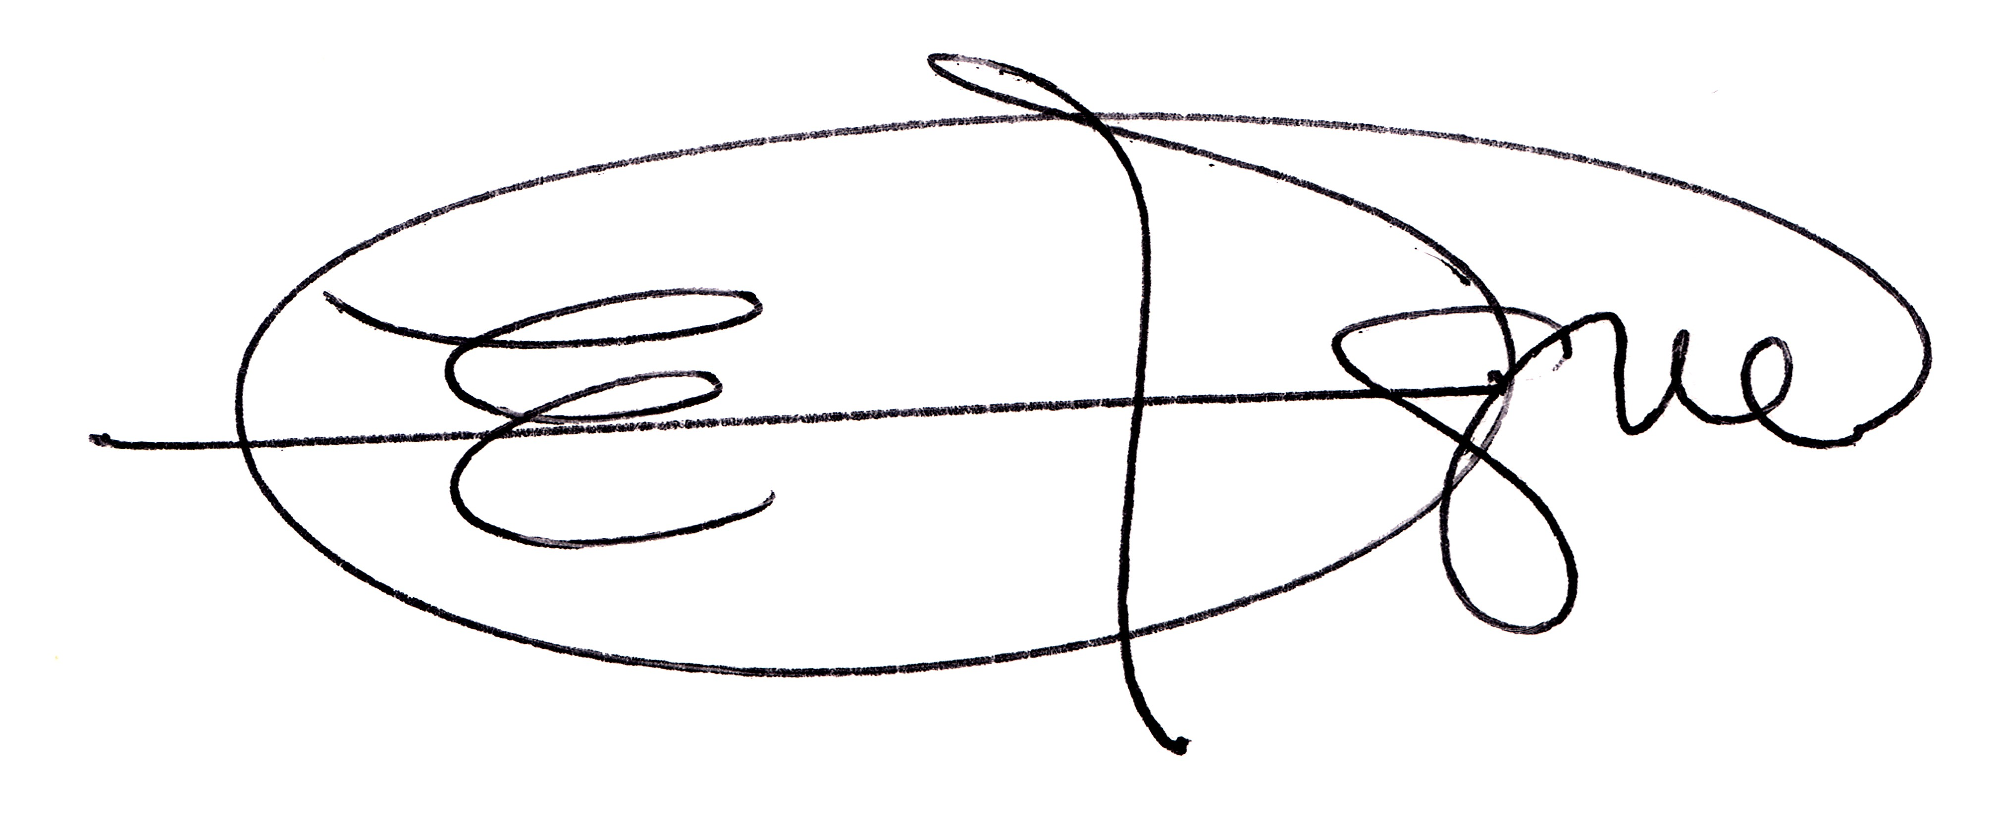

Enrique F. Maldonado Montero PhD.
Andalucia Tech – University of Malaga
Department of Psychobiology and Behavior
School of Psychology
Campus Teatinos, C.P. 29071
University of Malaga (UMA)
Spain
Phones:
+34-952133476 (Office)
+34-952133478 (Child Neuropsychology Lab)
+34-665537341 (Cellular)
e-Mail address:
fcomm@uma.es (UMA)
efcomm@gmail.com (Personal)
Twitter account: @EfcoMaldonado
Personal website: http://enriquefcomaldo.wordpress.com

